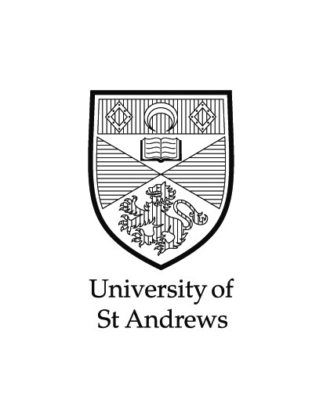
PHOTOGRAPH RELEASE FORM

COLLABORATIONS & STUDY ABROAD PHOTO COMPETITION

Status: Study Abroad, WIYA, External Placement?
Name (please provide first name and surname for our records however only your first name will be used in print) :
Email Address:
Host Country:
Host Institution:
Which subjects are you studying at St Andrews?

TITLE & BRIEF DESCRIPTION OF PHOTOGRAPHS ENTERED:

1.

2.

3.

CONSENT

I give my consent for the University of St Andrews to use my name, home town and degree details, together with my photograph and any text that I have provided, in relevant University-wide and School-specific publicity materials, such as prospectuses and subject leaflets, as well as on the University’s website. I also understand that my profile text may be edited. All contents of the publications are copyright of the University of St Andrews.

Name: Date:

Print & Design - Publications, University of St Andrews, St Andrews, KY16 9AX
Tel: (01334) 463020 / 7457
Email: publications@st-andrews.ac.uk
www.st-andrews.ac.uk/printanddesign/publications

The University of St Andrews is a charity registered in Scotland. No: SC013532

